Name: Pranali Sonawane
Subject: MCSA
Date: 22-01-2026
Lab 27: PowerShell

Server 1:
Open Windows PowerShell :

- Create 10 Users :
- New-ADUser – SamAccountName “Pranali” -UserPrincipalName “Pranali@Amazon.com” -AccountPassword(ConvertTo-SecureString “Password@123” -AsPlainText -Force) -Enabled $true

- New-ADUser – SamAccountName “shiv” -UserPrincipalName “shiv@Amazon.com” -AccountPassword(ConvertTo-SecureString “Password@123” -AsPlainText -Force) -Enabled $true

- New-ADUser – SamAccountName “Abhi” -UserPrincipalName Abhi@Amazon.com -AccountPassword(ConvertTo-SecureString “Password@123” -AsPlainText -Force) -Enabled $true

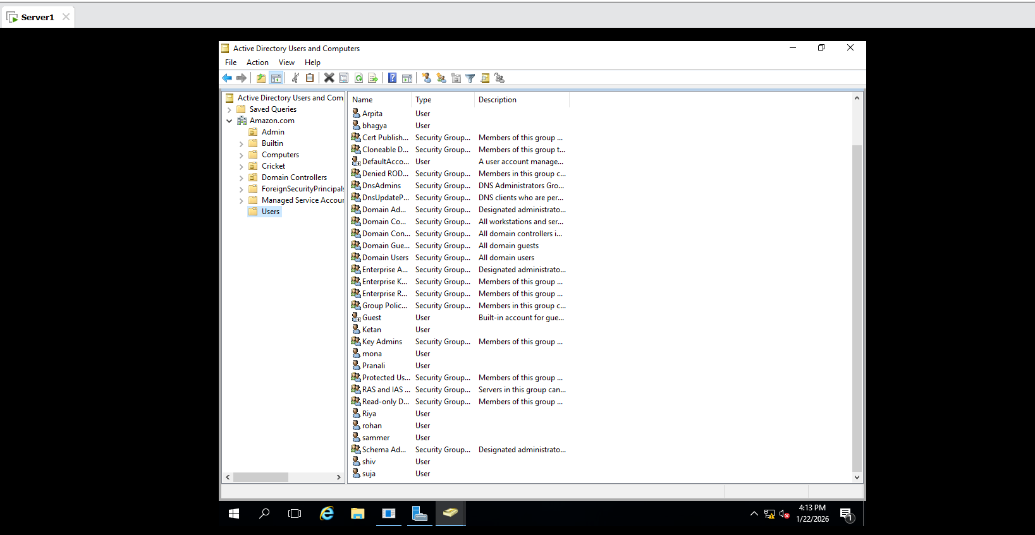

- Create 2 Group :
New-ADGroup -Name "Group1" -GroupScope Global
New-ADGroup -Name "Group2" -GroupScope Global

- Move 5 Users to Group1 and Group2 :
Add-ADGroupMember -Identity Group1 -Members Pranali
Add-ADGroupMember -Identity Group2 -Members Abhi
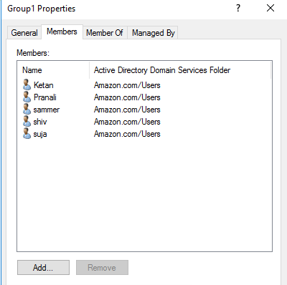
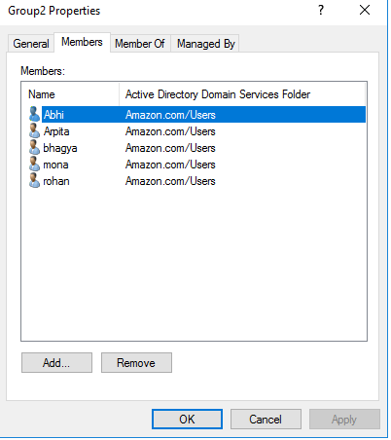

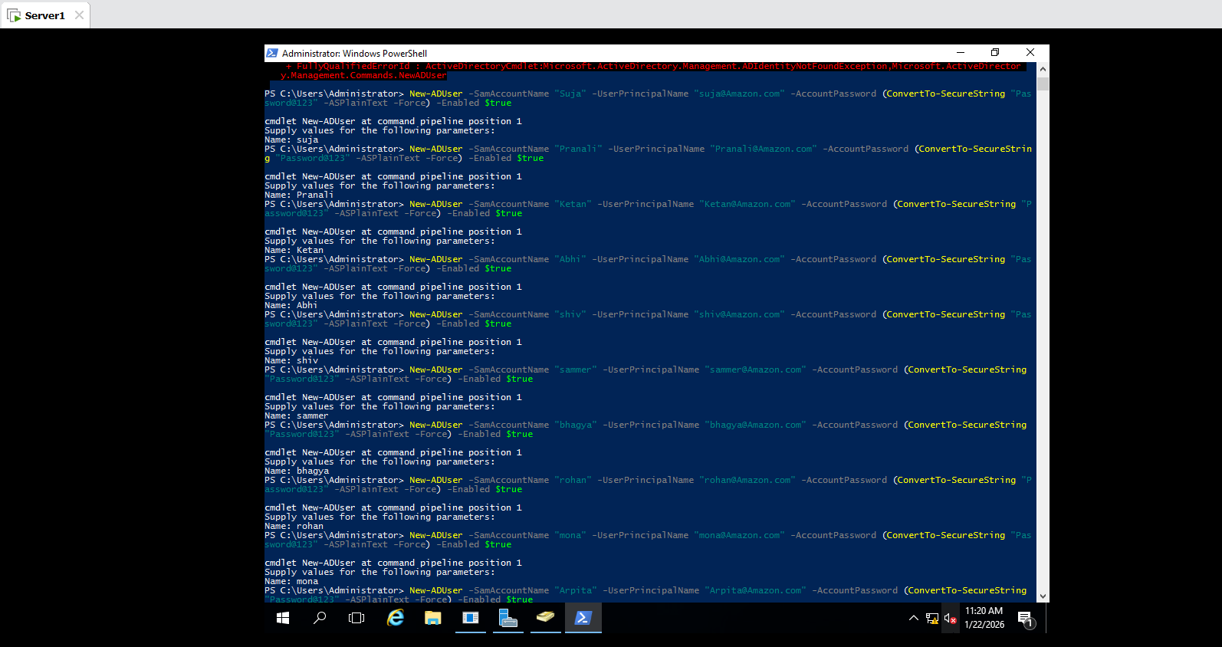
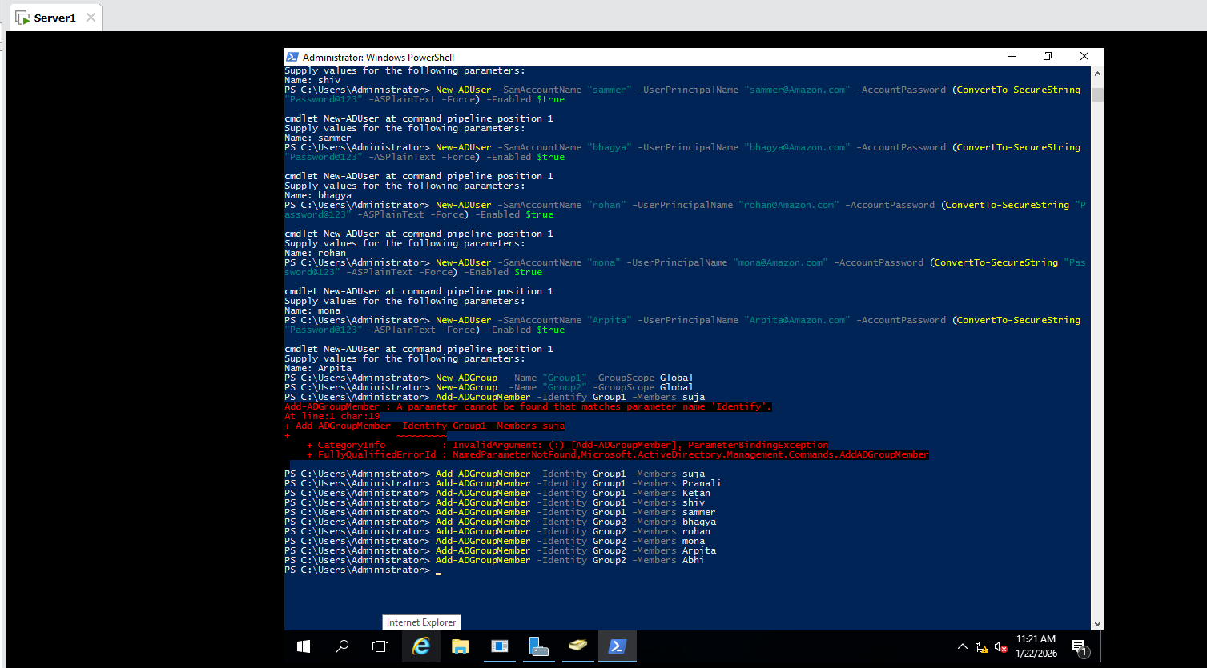

- Create OU Cricket ,Move groups to OU,Create a GPO , link to OU and GPO used in Powershell step step commands:

STEP 1: Create OU Cricket
New-ADOrganizationalUnit -Name "Cricket" -Path "DC=amazon,DC=com"

STEP 2: Move Groups to OU Cricket
- Move-ADObject -Identity "CN=Group1,CN=Users,DC=amazon,DC=com" `-TargetPath "OU=Cricket,DC=amazon,DC=com"

- Move-ADObject -Identity "CN=Group2,CN=Users,DC=amazon,DC=com" `-TargetPath "OU=Cricket,DC=amazon,DC=com"
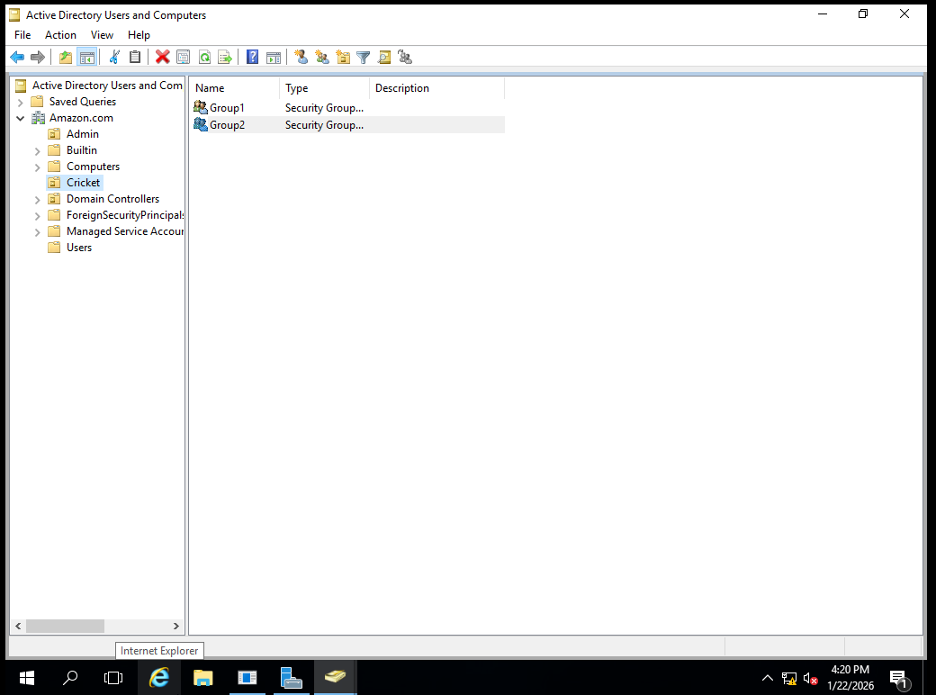
STEP 3: Create a GPO
New-GPO -Name "Cricket"

STEP 4: Link GPO to Cricket OU
New-GPLink -Name "Cricket" `
-Target "OU=Cricket,DC=amazon,DC=com"

- Intialise hard disks Format hard disks Create RAID 5 volume with powershell.

Server 1: Add 3 Hard Disk :

Step 2: Initialize the Disks
Get-Disk | Where-Object PartitionStyle -Eq ‘RAW’| Initialize-Disk -PartitionStyle GPT

Step 3: Convert Disks to Dynamic
- RAID-5 requires Dynamic Disks :
Get-Disk | where-object IsSystem -Eq $false |Set-Disk -IsReadOnly $false
Get-Disk | where-object IsSystem -Eq $false |Set-Disk -IsOffline $false

- Convert to Dynamic:
Diskpart

Inside diskpart:

list disk
select disk 1
convert dynamic
select disk 2
convert dynamic
select disk 3
convert dynamic
exit

Step 4: Create RAID-5 volume :

diskpart

Inside diskpart:

list disk
create volume raid disk=1,2,3
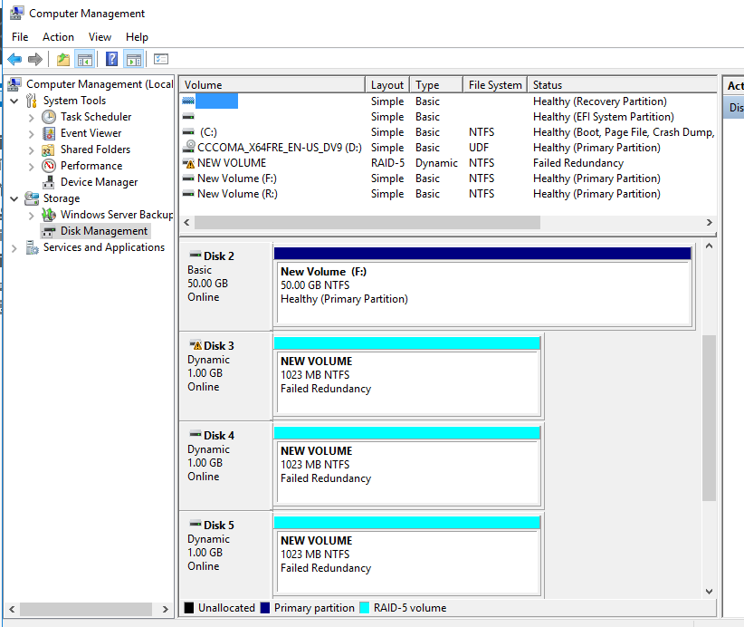

- Remove Dhcp service from server1,Install Dhcp service ,Start Dhcp service in power shell:
- Remove (Uninstall) DHCP Service from Server1:

- Uninstall-WindowsFeature DHCP -IncludeManagementTools

- Install DHCP Service on Server1:

--install-WindowsFeature DHCP -IncludeManagementTools

- Start DHCP Service:
-Start-Service DHCPServer
- Check DHCP Service Status:

-Get-Service DHCPServer

